Uniform Policy Sept 2019

It is our school policy that all children wear school uniform when attending school, or when participating in a school-organised event outside normal school hours.

Our school uniform is smart, easy to wash and enables pupils to access all areas of the curriculum easily and comfortably.

We believe that it:
- Engenders a sense of community and belonging to the school
- Makes children feel equal to their peers in terms of appearance
- Prevents children being distracted from their learning by concerns about the latest fashion
- Ensures that no children are restricted from any aspects of the curriculum by their choice of clothes
- Provides equal opportunities regardless of pupils’ culture, race, religion, gender, disability or ability.

It also generates a sense of pride in appearance which reflects the high standards that we encourage as a school.

The Governing body will respect variations to our school uniform if they are directly related to established religious or cultural traditions. However, any variation will be dealt with on an individual basis and judgements will remain at the discretion of the Head Teacher and the Governing Body.

Items of uniform with the school logo can be bought from the school office including sweatshirts, fleeces, polo shirts. Please pop along and ask. We also sell fine-point permanent markers so that parents can write names onto clothes labels.

Footwear
We expect our children to be active in the playground.
They need to have footwear that will allow them to safely run, jump, climb and chase on hard and grassy surfaces amongst lots of other children. For this reason, we don’t encourage ‘crocs’ or flimsy sandals which invariably lead to an increase in playground injuries. To avoid blisters, we also expect children to wear socks or tights with their shoes
Footwear
Please make sure it:
- Encloses the feet
- Provides support under the feet
- Is low heeled
- Is black (completely black trainers are fine as long as there is a change of footwear for PE)

Make Up
No make up or nail varnish should be worn on nails or toes.

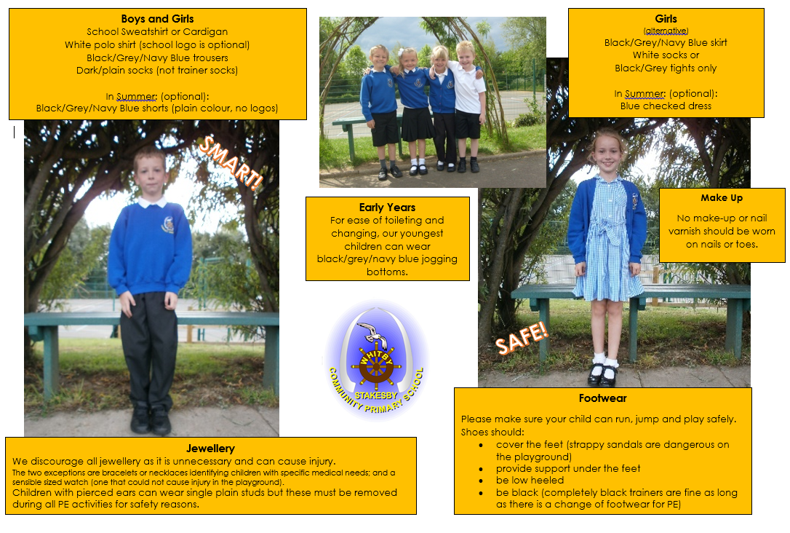

Uniform
Jewellery
The wearing of all jewellery, including ear-rings is strongly discouraged as it is unnecessary and can be dangerous in certain school situations.
The two exceptions are bracelets or necklaces identifying children with specific medical needs; and a sensible sized watch (one that could not cause injury in the playground).
Should a pupil have pierced ears, single plain studs only should be worn and in order to comply with health and safety regulations, must be removed during
all PE activities.
Please note that the school are unable to take any responsibility for removing or reinserting ear studs, or for locating lost studs.

Hair
We recommend that hair should be neat and tidy and worn with no extremes of style or colour. Any style or colour deemed inappropriate by the school will first result in a discussion with the Headteacher who will attempt to find reconciliation, but whose word is final, subject to appeal processes.
Long hair should be tied back during PE lessons for safety.

Equipment
- No knives or sharp blades should be brought into the school under any circumstances.
- Mobile phones should not be brought into school without the permission of the Head teacher.
- Medicines should not be brought to school by a child, with the exception of inhalers or epi-pens. Any other medication should be given in to the school office or to the class teacher by an adult.
- No money should be brought to school unless for a specific permissible purpose.
- Bags to carry equipment and belongings, should be of a reasonable size as space in the cloakrooms is limited.

Role of the Head teacher and Governing Body
The Head teacher is to ensure that pupils comply with the uniform policy agreed by
the governing body.
The Headteacher has a duty to enforce the school uniform as part of the duty to maintain day to day discipline in the school.
The Governing body will be receptive to any reasonable complaint from parents or carers, concerning uniform, handling it respectfully, considering fully the issues they raise. They will aim to work with parents to arrive at a mutually acceptable outcome.

Role of the Parents/Carers
Parents and carers are to ensure that their child / children adhere to the school’s uniform policy.
If they wish to raise any complaints about the school uniform, they will do this by following the schools complaints procedure.

Non-Compliance with the School Uniform Policy
Staff may challenge a pupil for breach of the Uniform/Appearance Policy. The Headteacher may contact parents/carers if considered appropriate.
Where the breach is considered ‘persistent and defiant’, the Headteacher, or another member of staff with delegated authority, may ask a pupil to go home to remedy the situation. In such a case, any absence associated with this will be recorded as ‘authorised’.

