The Enquire Learning Trust

19th March 2020

Dear Parents/Carers
Re: Coronavirus update – school closure to most pupils

I am writing to let you know that we have now been instructed to close the school to almost all children after this Friday until further notice.

As advised by the government, we will do all we can to stay open for the children of key workers (e.g. NHS staff, police, others in frontline services) and children with certain needs.

We are waiting for the government to publish more information on what this means, but it would help us in the meantime if you could let us know if you think your child may fall into one of these categories by emailing Miss Robson at e.robson@stakesbyschool.net. In the email, please advise Miss Robson your child’s name, class and your profession. We’ll be in touch again as soon as we are sure who this does apply to.

All other children will need to stay at home, so we ask that you do not send your child into school from Monday onwards.

Please note that this is a national closure – as you may have heard in the news – so while it is a challenging situation, we are not alone. We’ll re-open fully as soon as we can and will let you know when this is through Facebook and on our website.

What we’ll continue doing while your child is at home
Your child’s learning is of course important to us, so we’ll continue to help your child to learn.

Please be aware that the pack of work we have sent home for each child will cover the next two weeks of learning. There is nothing that your child has received that they haven’t covered in class. Teaching staff will be available for contact via email if there are any issues, however please be aware that in light of school remaining open for key workers’ children, your child’s teacher may not be able to respond immediately.

Teachers will be 'checking in' with their classes at 9am each morning via Teams.

The information you received regarding learning via Teams is to be used after the Easter holidays (Tuesday 21st April) - if school remains closed. Teams will be used as a class contact base and for teaching staff to issue instructions around learning.

If staff are absent due to isolation and/or illness, this is subject to change and we will update you as soon as possible. Similarly, we will continue to follow government and Trust advice which may change as the situation alters. Again, we will update you via the school Facebook page and website as soon as possible.

Parents and pupils will be able to contact the school and their teacher(s) via email and ‘Teams’

If your child usually receives free school meals, we will also be in touch with more information about how we will continue to provide this, with support from a scheme that the government has just announced.

What we won’t be able to go ahead with
- Events including all FoSS events
- Internal exams or tests

This is as much as we know right now, and we appreciate your continued patience with as we deal with this ever-changing situation. We understand that this latest news will have an impact on you and your family and it’s far from ideal, but we’ll continue to keep in touch with any updates as the situation develops. If you want to get in touch to share any concerns, please don’t hesitate to do so via email at admin@stakesbyschool.net

And remember: if you or your child feels ill and you want to know what to do next, please use NHS 111 online.

Thank you again for your continued support, and we will be in touch with more information when we can.

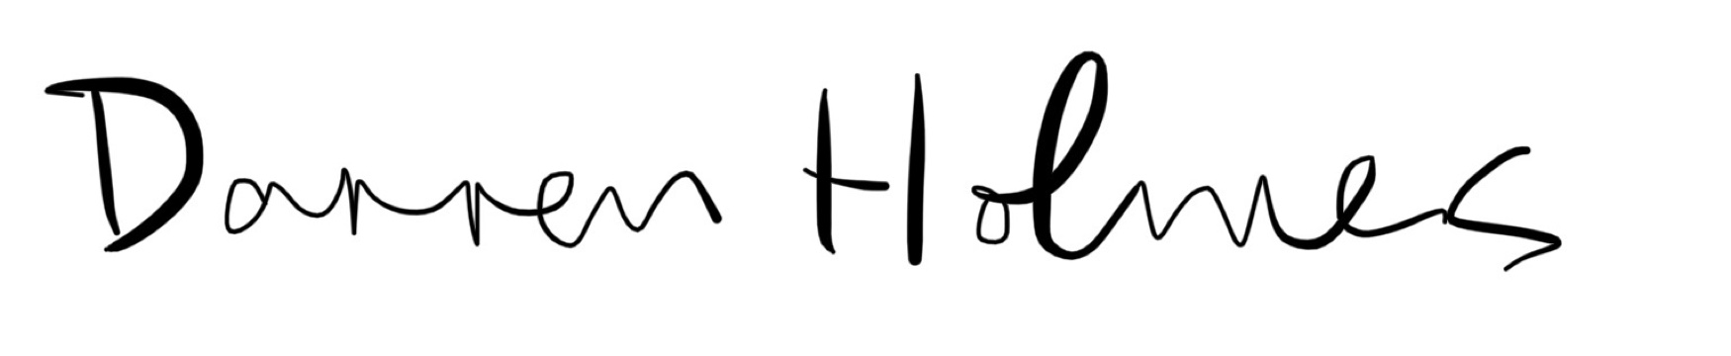

Darren Holmes
Chief Executive Officer of Enquire Learning Trust

