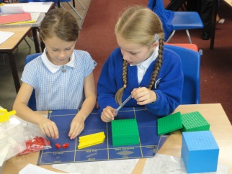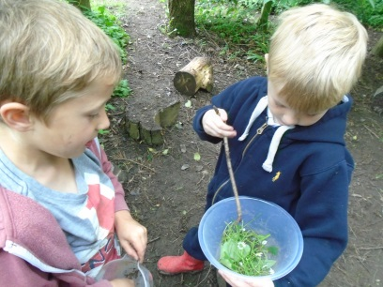
Come and join us for some of the following activities...
9am-10.30am
EYFS | Holly  Year 1 | Beech  Year 2 | Maple  Year 3 | Ash  Year 4 | Elm  Year 5 | Oak  Year 6
Free flow and carpet session (maths/phonics) | Phonics  Easter maths | Easter-themed poetry | Guided reading and ICT | Guided Reading  Forest Schools | Guided Reading  Poetry Writing | Outdoor grammar and creative writing
10.30am – The Grand Opening of the EYFS Play equipment – please join us up in Acorn’s playground.
10.45am – Refreshments in the hall
10.45am-12pm
EYFS | Holly  Year 1 | Beech  Year 2 | Maple  Year 3 | Ash  Year 4 | Elm  Year 5 | Oak  Year 6
Free flow and carpet session (maths/phonics) | Circle Time  Literacy | Maths Easter Egg classroom hunt – positional language | Circle time and Maths problem solving | Forest Schools | Problem solving | Problem solving in maths
12pm – Parents to depart
12.10-1.10pm – Lunchtime for the children
1.30-2.15pm
EYFS | Holly  Year 1 | Beech  Year 2 | Maple  Year 3 | Ash  Year 4 | Elm  Year 5 | Oak  Year 6
Free flow and carpet session (maths/phonics) | Easter Art | Easter Art | Forest School Art | PE/Cricket | Computing | Quad Kids at Caedmon
2.15-3.00pm
EYFS | Holly  Year 1 | Beech  Year 2 | Maple  Year 3 | Ash  Year 4 | Elm  Year 5 | Oak  Year 6
Free flow and carpet session (maths/phonics) | Easter Art  Storytime | Spelling games and storytime | PE/Cricket | Creative writing | Computing | Quad Kids at Caedmon
3pm – Parents to depart

Why hold an Open Day?
In a nutshell, we are incredibly proud of our school, the fantastic children and teachers we have and the wide range of learning opportunities we offer our pupils on a daily basis. We want you to have the chance to experience what life at Stakesby is like - whether you currently have children in the school or just want to have a look around!
Safeguarding information
At Stakesby School, safeguarding is of paramount importance. Open Day at Stakesby is no exception. Please be assured that we have assessed potential risks and have put measured plans in place to ensure the children are safe in school at all times, as we welcome families, friends and members of the public to visit us during the day.
Arrangements for the Day – Ensuring the Safety of All
Signing in
On arrival, all visitors will be asked to sign in. This is essential as we need to know who is in the building at any time, particularly in the event of an emergency, such as a fire. Visitors arriving at the beginning of the school day can come into school via the front entrance or the playground door. Signing in will take place at both entrances, manned by staff. At 9am, the gates will be locked and from that point on, visitors will only be able to enter the school via the front door.
Staff
Be assured that all teaching spaces and areas in school will be manned sufficiently by school staff. Many members of staff who do not usually work on Wednesdays have offered to come into school for Open Day in order to provide additional safeguarding support. This also gives any visitors increased opportunities to ask questions or discuss the learning that is taking place in classes.
Transition Times
School Staff will guide visitors around school where necessary. A bell will sound at 10.30, this will be for parents to go to the EYFS playground for our grand opening of the play equipment. This also enables the children to have their usual playtime. At 12pm a bell will sound; this is to indicate that the morning part of Open Day has finished. The same bell will ring at 3pm, indicating an end to Open Day. Unlike the Fairs that we hold annually, the children remain in the care of the teachers throughout the day. If your son/daughter gets distressed during the visit, experience has shown us that a quick parental exit enables us to encourage the child to settle much quicker! All children will leave school at 3.15pm and usual arrangements will apply.
Photographs and Mobile Phones
School staff will take photographs during the day and will put a selection on our social medial accounts. Unfortunately, taking photographs in school will not be permitted. We also respectfully request that mobile phones will be kept in pockets/bags for the duration of your time in school. Staff have been briefed to approach anyone using a mobile device in school.
All visitors will also be reminded that the school is a no dog zone, no smoking zone and this includes e-cigarettes. Thank you for your support with this.

And finally…We are really looking forward to opening our school and showcasing our learning to you. We hope you will join us for a time on Wednesday and look forward to seeing you then!

